**Hough Circle Write-Up**

This assignment wasn’t super difficult, but it was interesting. Thankfully, the circle calculation was done for me, which would have been the hardest part. Drawing all of those circles on top of the original image was also not too difficult. The real challenge came from the K means clustering algorithm. I was trying to figure out data structures and ended up just making a class to store the x, y, and radius. There’s probably a better way but I was feeling lazy. I did a few iterations manually to verify that the correct mean and circle was being chosen. Thankfully it did, so I just allowed the remaining iterations to run, then averaged out all the groups.

All Circles

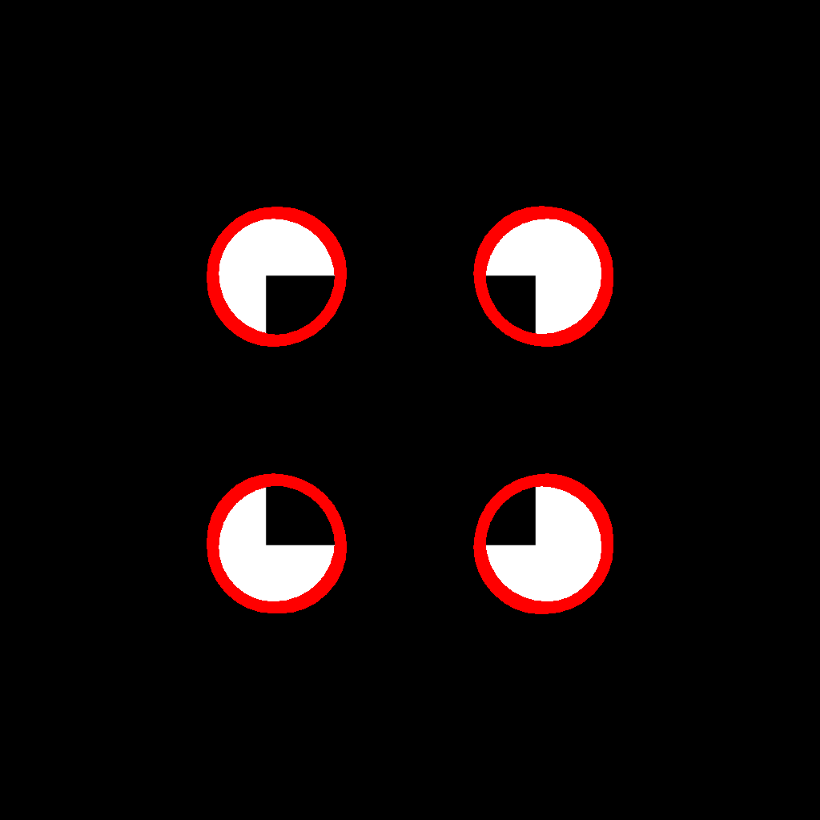

Post K means clustering

